DBFirst Approach

DB is ready

Tables are ready with data

Step1: Install packages

Microsoft.EntityFrameworkCore;

Microsoft.EntityFrameworkCore.SqlServer;

Microsoft.EntityFrameworkCore.Tools;

or

<ItemGroup>

<PackageReference Include="Microsoft.EntityFrameworkCore" Version="8.0.18" />

<PackageReference Include="Microsoft.EntityFrameworkCore.SqlServer" Version="8.0.18" />

<PackageReference Include="Microsoft.EntityFrameworkCore.Tools" Version="8.0.18">

<PrivateAssets>all</PrivateAssets>

<IncludeAssets>runtime; build; native; contentfiles; analyzers; buildtransitive</IncludeAssets>

</PackageReference>

</ItemGroup>

Step2:

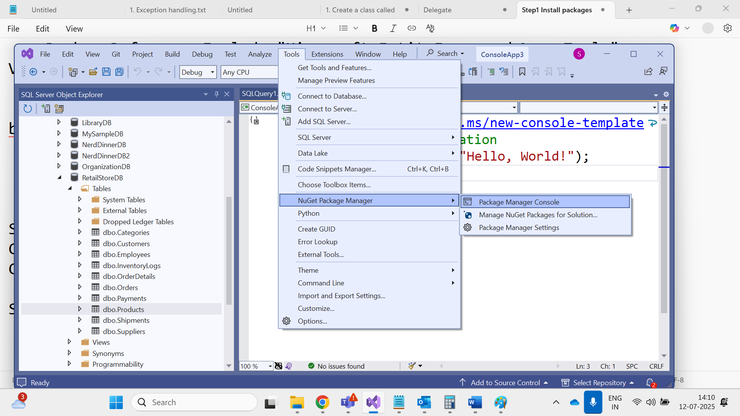

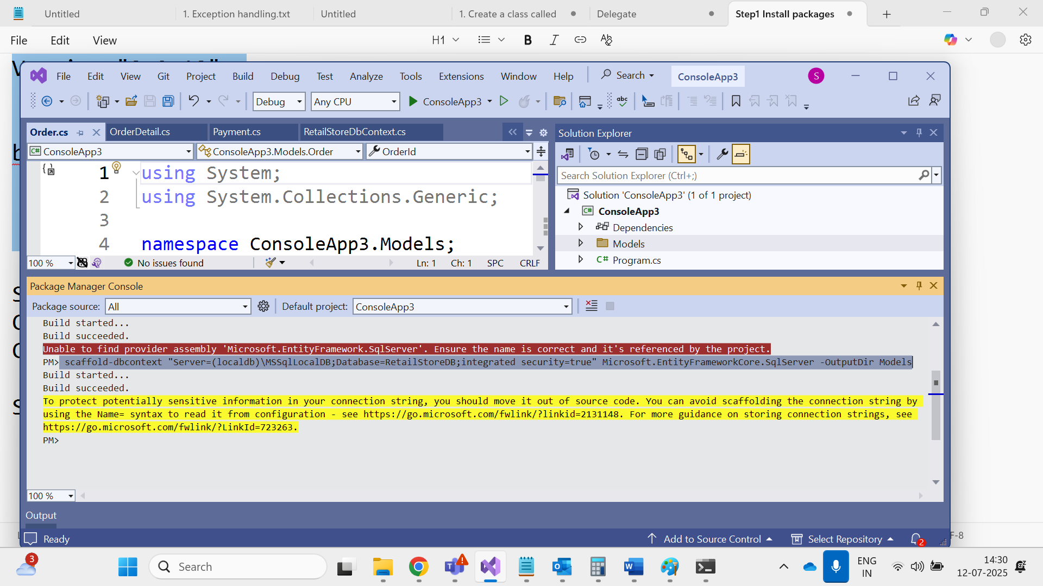

Scaffold-dbcontext “Server=(localdb)\MSSqlLocaldb;Database=RetailStoreDB;Integrated Security =true” Microsoft.EntityFrameworkCore.SqlServer -outputDir Models

Database == RetaildStoreDBContext class

Connects with database

Track changes to db

Save changes to db

each tables becomes an entity class in the models folder

And each table is a property inside context class

For Any and every intereaction with db , create an object Context class

internal class EmployeeRepository

{

RetailStoreDbContext db = new RetailStoreDbContext();

public void GetAllEmployees()

{

List<Employee> emps = db.Employees.ToList();

foreach (var e in emps)

{

Console.WriteLine($"{e.EmployeeId} {e.FirstName} {e.LastName} {e.Email}");

}

}

public void GetEmployeeByID(int id)

{

Employee emp = db.Employees.Where(e => e.EmployeeId == id).Single();

Console.WriteLine($"{emp.EmployeeId} {emp.FirstName} {emp.LastName} {emp.Email}");

}

public void UpdateEmployeeSalary(int id,decimal salary)

{

Employee emp = db.Employees.Where(e => e.EmployeeId == id).Single();

emp.Salary = salary;

db.SaveChanges();

Console.WriteLine($"Updated salary of {id} employee");

}

public void DeleteEmployeeByID(int id)

{

Employee emp = db.Employees.Where(e => e.EmployeeId == id).Single();

db.Employees.Remove(emp);

db.SaveChanges();

Console.WriteLine($"Deleted an employee with {id} id");

}

public void AddNewEmployee(Employee emp)

{

db.Employees.Add(emp);

db.SaveChanges();

Console.WriteLine("Added new employee");

}

}

using ConsoleApp3.Models;

using ConsoleApp3;

EmployeeRepository obj = new EmployeeRepository();

//obj.GetAllEmployees();

//obj.GetEmployeeByID(3);

//obj.UpdateEmployeeSalary(1, 80000);

//obj.DeleteEmployeeByID(5);

Employee newemp = new Employee() { FirstName = "Kartik", LastName = "Balija", Email = "Karthik@hotmail.com", Salary = 23455 };

obj.AddNewEmployee(newemp);